**Ganpat University**

**Faculty of Engineering & Technology**

**Computer Science & Engineering**

**Practical_2**

***Name:- Dwij Vatsal Desai***

***Sem:- 3***

***Sub: - DBMS­­***

***Enrollment No.:- 23162121027***

# Retrieving records from table

* 1. Find out the names of all clients.

Query: select name from client_master;

Image: 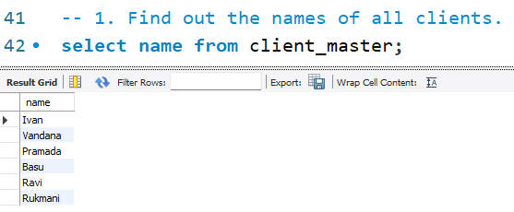

2. Create table client_master.

Query:

use Dwij_BDA1027;

create table client_master(Client_no varchar(20),Name varchar(20),City varchar(20),Pincode int(20),State varchar(20),Bal_due int(20));

Image: 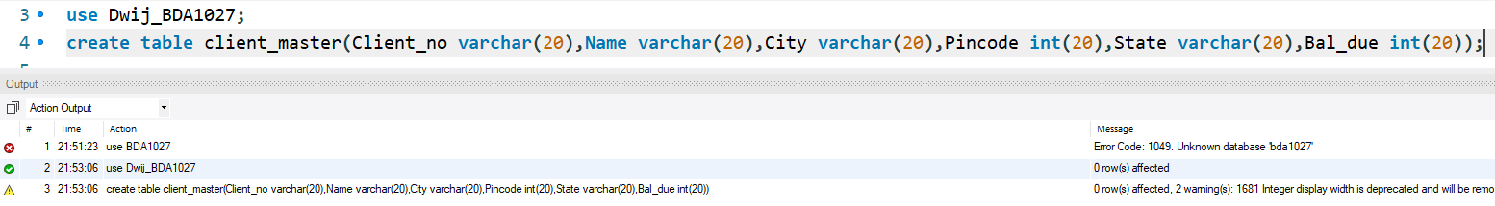

3. Create table product_master.

Query:

create table product_master(Product_No varchar(20),Description varchar(20),P_percent int(20),U_Measure varchar(20),Qty_on_hand int(20),Reorder_lvl int(20),sell_price int(20),Cost_price int(20));

Image:



4. Create table salesman_master.

Query:

create table Salesman_master(S_no varchar(20),S_name varchar(20),City varchar(20),Pin int(20),State varchar(20),Sal_Amt int(20),Tgt_toget int(20),Ytd_Sales int(20),Remarks varchar(20));

Image:

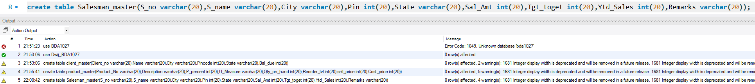

5. Describe structure for client_master table.

Query:

desc client_master;

Image:

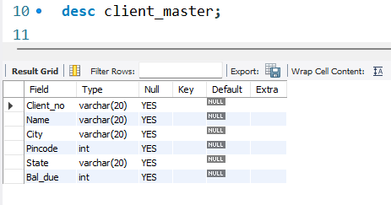

6. Describe structure for product_master table.

Query:

desc product_master;

Image:

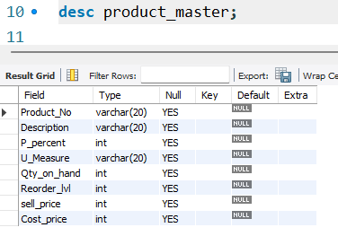

7. Describe structure for salesman_master table.

Query:

desc Salesman_master;

Image:

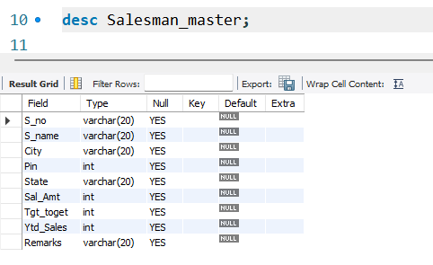

8. Insert records in client_master table.

Query:

-- client_master;

insert into client_master values('C001','Ivan','Bombay',400054,'Maharashtra',15000);

insert into client_master values('C002','Vandana','Madras',780001,'Tamil Nadu',0);

insert into client_master values('C003','Pramada','Bombay',400057,'Maharashtra',5000);

insert into client_master values('C004','Basu','Bombay',400056,'Maharashtra',0);

insert into client_master values('C005','Ravi','Delhi',100001,'Gujarat',2000);

insert into client_master values('C006','Rukmani','Bombay',400050,'Maharashtra',0);

select * from client_master;

Image:

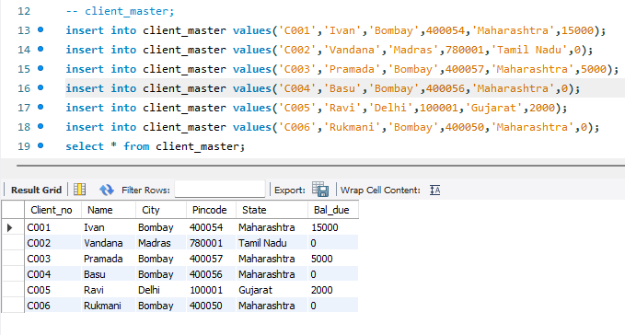

9. Insert records in product_master table.

Query:

-- drop table product_master;

insert into product_master values('P001','Floppies',5,'Piece',100,20,525,500);

insert into product_master values('P002','Floppies',6,'Piece',10,3,12000,11280);

insert into product_master values('P003','Floppies',5,'Piece',20,5,1050,1000);

insert into product_master values('P004','Floppies',5,'Piece',100,20,525,500);

insert into product_master values('P005','Floppies',2,'Piece',10,3,3150,3050);

insert into product_master values('P006','Floppies',2.5,'Piece',10,3,5250,5100);

insert into product_master values('P007','Floppies',4,'Piece',10,3,8400,8000);

select * from product_master;

Image:

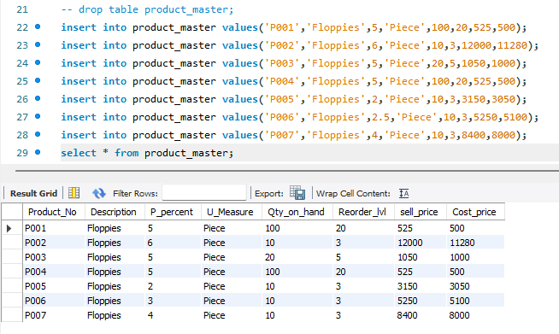

10. Insert records in salesman_master table.

Query:

-- Salesman_master;

insert into Salesman_master values('S001','Kiran','Bombay',400002,'Maharashtar',3000,100,50,'Excellent');

insert into Salesman_master values('S002','Manish','Bombay',400001,'Maharashtar',3000,200,100,'Good');

insert into Salesman_master values('S003','Ravi','Bombay',400032,'Maharashtar',3000,200,100,'Average');

insert into Salesman_master

values('S004','Ashish','Bombay',400044,'Maharashtar',3500,200,150,'Good');

select * from Salesman_master;

Image:

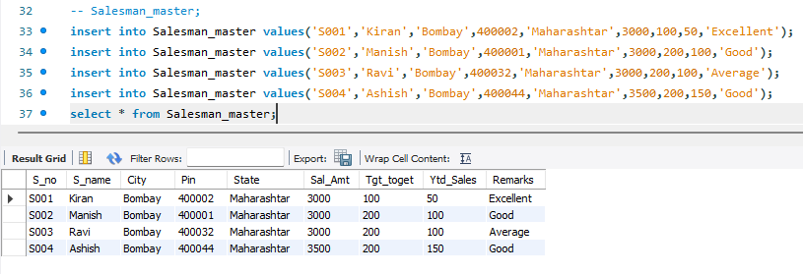

11. Retrieve all records for client_master table.

Query:

select * from client_master;

Image:

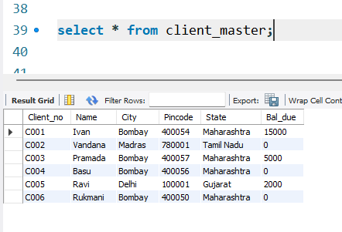

12. Retrieve product_no, sell_price and cost_price for

product_master table.

Query:

select product_no, sell_price, cost_price from product_master;

Image:

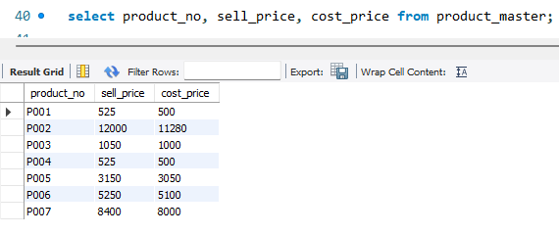

13. Retrieve s_no,s_name, remarks and sal_amt for salesman_master table.

Query:

select s_no, s_name, remarks, sal_amt from salesman_master;

Image:

